29th May 2017

**FIA WTCC Race of Germany heats up Championship**

Thed Björk and Nicky Catsburg can be very pleased with their performance at the “Green Hell”, during the weekend’s much anticipated FIA World Touring Car Championship Race of Germany at the Nuerburgring.

The winners for the Polestar Cyan Racing team added spice to a hotly contested World Touring Car Championship title race which has the Japanese tyre manufacturer YOKOHAMA as Official tyre supplier.

With around 200,000 spectators lining the legendary 25.3km track, the Swede Björk charged through from sixth on the grid to win the Opening Race with Mehdi Bennani second and Rob Huff managing to slip past Tom Chilton towards the end to make it to the podium on third.

Meanwhile Nicky Catsburg snatched the lead starting the Main Race. The Dutchman held firm for his second WTCC victory and his first driving a Volvo S60 Polestar. Catsburg was followed by Pole man Norbert Michelisz and Rob Huff once again managing a credible third place. Catsburg’s excellent race and points obtained means he is now two points in front in the title standings.

With the next race to be held in Portugal, the heat will intensify even further as Monteiro seeks to recover the lost ground in Germany.

In the WTCC trophy, Chelsea FC fan and talented driver Tom Chilton scored a WTCC podium double but it was not enough to prevent Rob Huff from moving back to the top of the standings by a single point over his fellow Citroën-driving Briton. Mehdi Bennani is third in the WTCC Trophy.

Overall Championship Standings

1 Nicky Catsburg 127

2 Tiago Monteiro 125

3 Thed Bjork 119

4 Tom Chilton 106

The next race will be held in Vila Real, Portugal from 23rd -25th June.

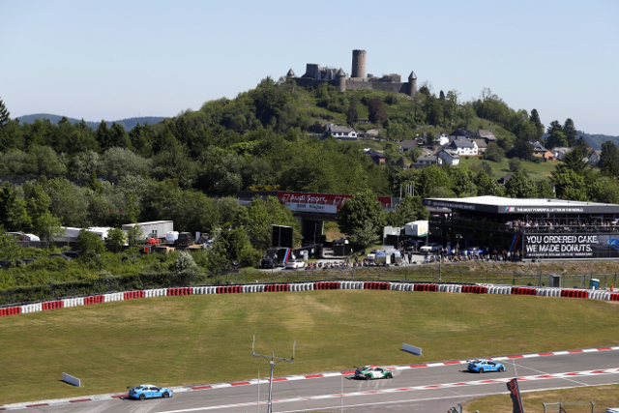

*The Green Hell was turned Blue by Volvo Polestar Cyan team*

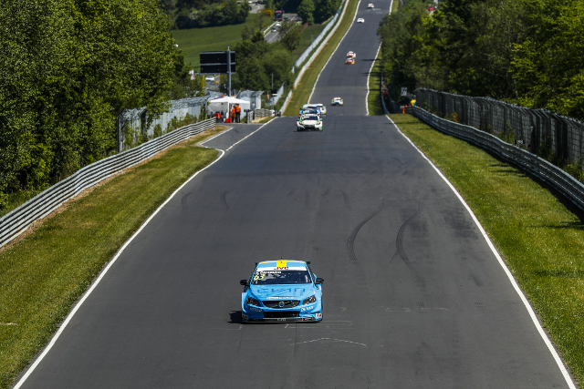

*Nicky Catsburg leads the Championship*

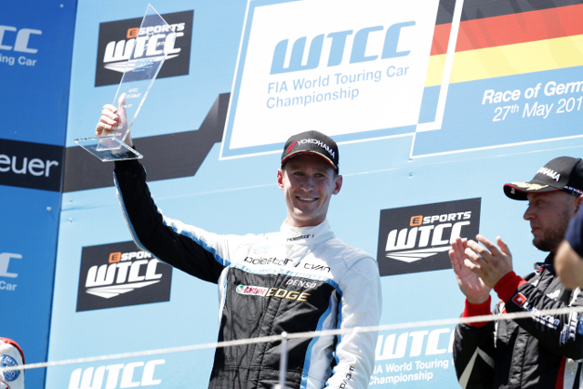

*Nicky Catsburg in top form*